

# Panasonic Cordless Phone KX-TG6821ALB

## Type of device: Landline - Cordless

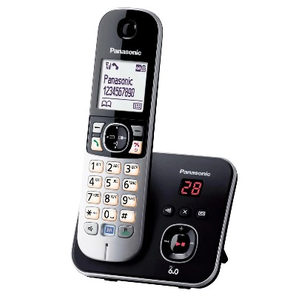

Actual Display Size : 1.8 inches

Button Type : Physical Keypad

Average Price : $53 as of 17 06 2021

## Accessibility Features:

### Hearing Impairment and Deaf

Visual Alerts - Incoming Calls

### Vision

* Battery Alert - Audible
* Brightness Adjustable
* Key Numbers - Standard Layout

Key Press - Vibration or Click

### Physical

* Automatic Answer
* Automatic Redial
* Guarded/Recessed Keys
* Physical Dialling Keys

Speaker-phone option

## How and where to get it from?

You can buy this phone from [Officeworks](https://www.officeworks.com.au/shop/officeworks/p/panasonic-cordless-phone-kx-tg6821alb-patg6821al#specifications), [The Good Guys](https://www.thegoodguys.com.au/SearchDisplay?categoryId=&storeId=900&catalogId=20000&langId=-1&sType=SimpleSearch&resultCatEntryType=2&showResultsPage=true&searchSource=Q&pageView=&beginIndex=0&orderBy=0&pageSize=60&searchTerm=Panasonic+Cordless+Phone+KX-TG6821ALB), [JB Hi-Fi](https://www.jbhifi.com.au/products/panasonic-kx-tg6821alb-cordless-phone?queryID=df47e7d4c38c781ac58bd4d2f817ee1d&objectID=429439), [Harvey Norman](https://www.harveynorman.com.au/catalogsearch/result/?q=Panasonic+Cordless+Phone+KX-TG6821ALB), and other retailers.

## More information is available on:

[Panasonic KX-TG6821ALB Cordless Phone Web Page](https://www.panasonic.com/au/consumer/household/cordless-phones/phone-with-answering-machine/kx-tg6821alb.html)

[Panasonic KX-TG6821ALB Cordless Phone User Manual (PDF Download)](https://www.panasonic.com/content/dam/Panasonic/support_manual/Cordless_Telephone/English_03-other/TG6821AL_PNQX5802ZA.pdf)